|  |  |
| --- | --- |
| **Course-** BTech | **Type**- Core |
| **Course Code-** CSET101 | **Course Name**- Computational Thinking and  Programming |
| **Year-** 2023 | **Semester-** odd |
| **Date-** | **Batch-** ALL |

# Tutorial Assignment: Week 3

**Tutorial title: Case sensitive nature and Operators.**

# CO Mapping

|  |  |  |  |
| --- | --- | --- | --- |
| **Name** | **CO1** | **CO2** | **CO3** |
| **Case sensitive nature** | ✓ | **-** | **-** |

**Python syntax** defines all the set of rules that are used to create sentences in Python programming.

## Case sensitive nature of Python

Python is a **case-sensitive programming language**. This means that it treats uppercase and lowercase letters differently. Hence, we cannot use two terms having same characters but different cases interchangeably in Python. For example: Using *print* and *Print* in Python will give different results. In Python's syntax, the keyword *print* should always be written in lowercase. Hence, using *Print* will lead to python not identifying the keyword resulting in NameError.

*Python Naming Standards*

•

•

•

•

Variable, functions, modules and package names are written in *lowercase* by convention. Class names and constants are written in *uppercase*.

We can ignore case in Python using the .*upper()* and *.lower()* methods.

*.upper()* converts the entire string to uppercase whereas *.lower()* converts a string

to lowercase.

## Operators:

The term operator refers to a symbol (or sometimes a phrase of alphabets) which is predefined to perform a certain process such as addition, comparison etc. Each symbol requires one or more objects for the process to be performed. The objects are called operands and symbol itself is called operator. Most of the operators are binary in nature, in the sense they require two operands. Unary operator requires only one operand. Arithmetic Operator Everybody is familiar with arithmetic operators performing addition, subtraction, multiplication and division. Python has additionally modulus exponent and floor operators.

# Arithmetic Operator

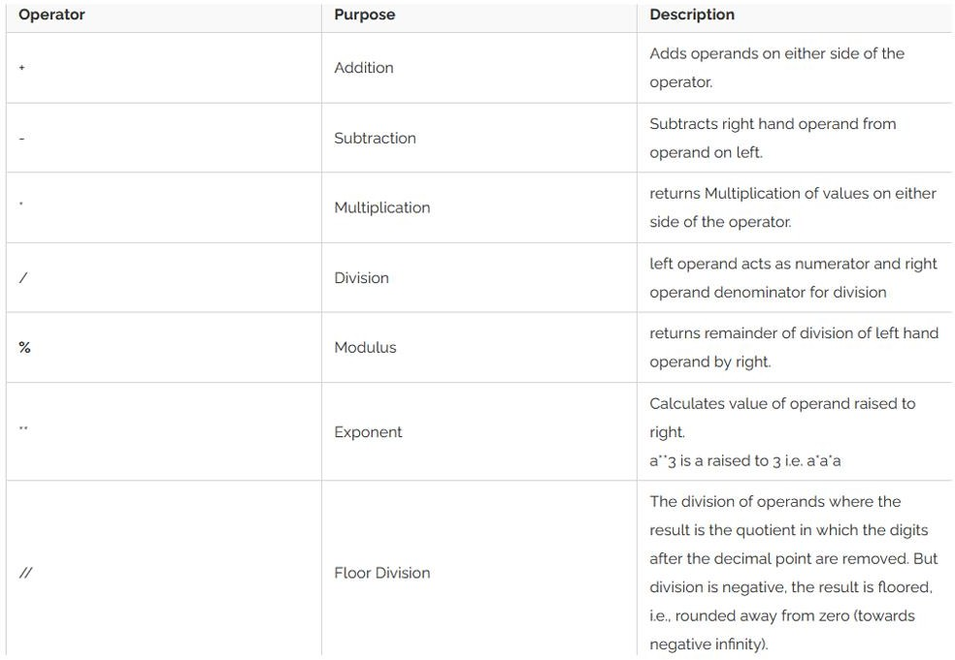Everybody is familiar with arithmetic operators performing addition, subtraction, multiplication and division. Python has additionally modulus exponent and floor operators. ECSE105L: Computational Thinking and Programming

# In place Assignment Operator

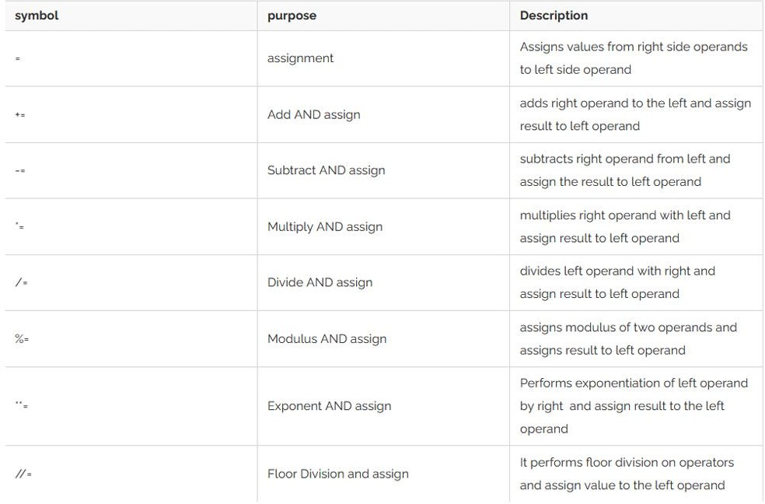These operators allow any arithmetic operation and assignment in one step. Result of corresponding arithmetic operation of two operands is assigned back to left operand.

# Logical Operator:

In order to compare two objects for equality or to decide whether one is greater than other etc. the logical comparis on operators are used. Primarily used with numeric objects, they can very well be used with other Python objects such as string, list or tuple

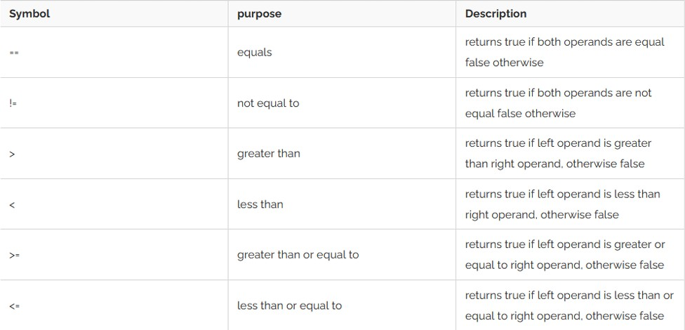

# Sequence Operator:

This category of operators is common to all sequence data type i.e. string, list and tuple. All of them use zero based index to access items in them. Hence operators for indexing and slicing have been commonly defined

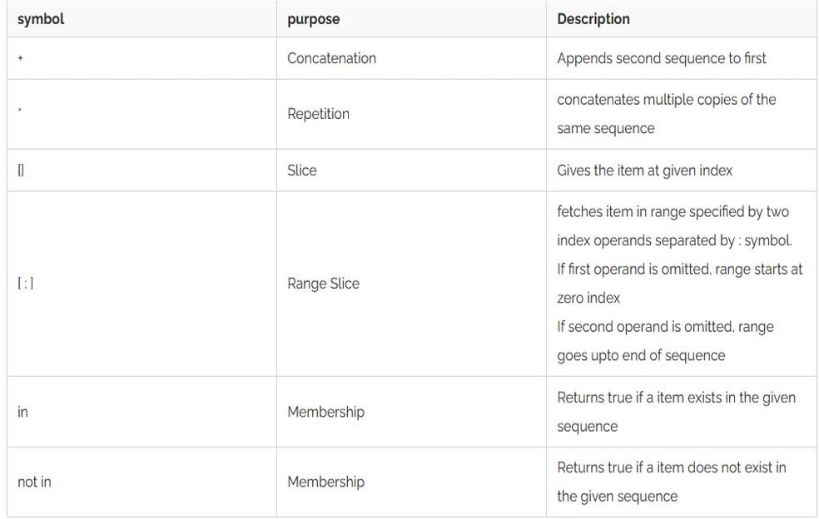

# Exercise:

1. **Is Python case sensitive when dealing with identifiers?**
2. yes
3. no
4. machine dependent
5. none of the mentioned

# What is the maximum possible length of an identifier?

1. 31 characters
2. 63 characters
3. 79 characters
4. none of the mentioned

# Which of the following is an invalid statement?

a) abc = 1,000,000

b) a b c = 1000 2000 3000

c) a,b,c = 1000, 2000, 3000

d) a_b_c = 1,000,000

# If we want to print the roundoff value upto two digit for 49.279 using format function, what will be the correct code:

1. txt = "For only {price:.2f} dollars!" print (txt.format(price = 49.279))
2. txt = "For only {price:.2f} dollars!" printf (txt.format(price = 49.279))
3. txt = "For only {price:2f} dollars!" printf(txt.format(price = 49.279))
4. None of these
5. **What will be the output:** user_name = 'User1' print(User_name)

# What will be the output?

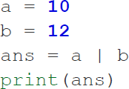

1. **Print the output.**

a = **5**

b = **9**

ans = a & b print(ans)

# Print the output.

var = **2**;

print("var = ", var<<**0**) print("var = ", var<<**1**) print("var = ", var<<**2**) print("var = ", var<<**3**) print("var = ", var<<**4**) print("var = ", var<<**5**)

# TIME TO REACH HOME

Sam left his home at 05:43 AM and ran 4 km at a slow speed. At slow speed Sam takes 9:32 min for each km. Thereafter, he speeded up and ran for 3 km taking 7:12 minutes for each km. He ran another 2.5 km at slow speed. Write a python program to find at what time he will reach home for breakfast.

# GIFT CARD REEDEMPTION

This program will calculate a restaurant tab for a couple with a gift certificate, with a restaurant tax of 18%. The couple will enter the items for person 1 and person 2 along with the gift certificate. The program should find the total cost of the order, restaurant tax . A negative amount indicates the amount left on the gift certificate. The sample execution is shown below:

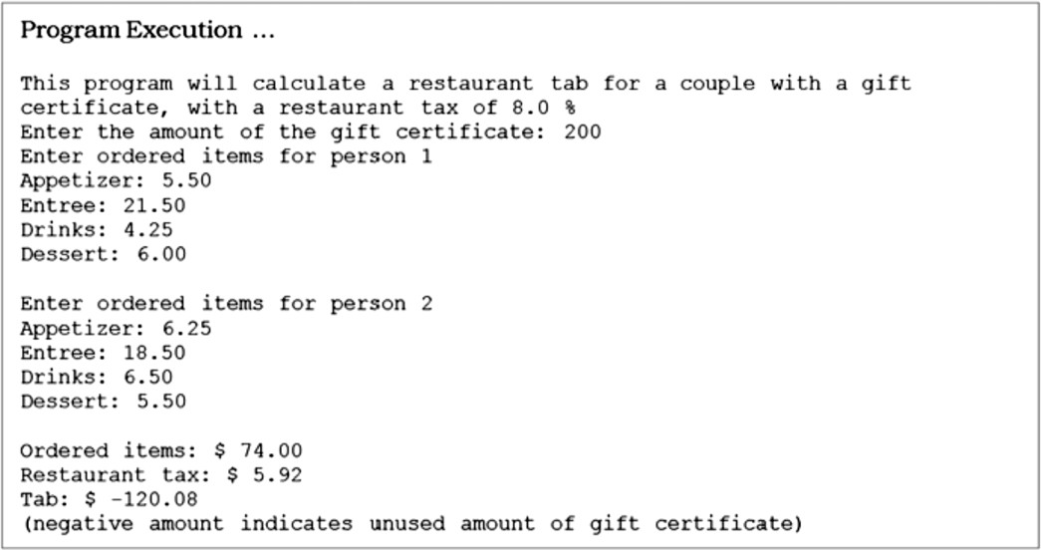

1. Find Error in the below program

def calculateArea(radius): PI = 3.1416

Print(PI * radius * radius)

circle_radius = 5 calculateArea(circle_radius)

# What is the output of print 0.1 + 0.2 == 0.3?

1. True
2. False
3. Machine dependent
4. Error View

# Which of the following cannot be a variable?

* 1. init
  2. in
  3. it
  4. on

1. Predict the outputs:

another_set = {"red", "green", "black"}

print(type(another_set)) print(another_set)

1. Predict the outputs:

a=9

b=3

print(a// b)

print(a// -b)

print(-a // b)

print(-a // -b)

1. Enter a N digit number and write a program to calculate the sum of its digit.
2. How to take multiple inputs in a single line: Python?
3. **Predict the output of following program**
   1. x = 10

print(x > 5 and x < 15)

* 1. x = 10

print(x > 5 or x < 2)

* 1. x = 10

print(not(x > 5 and x < 15))

* 1. num1 = 4

num2 = 5 res = num1 + num2 res += num1

print(("Line 1 - Result of + is ", res))

# print the output:

a = 5

b = 9

ans = a ^ b print(ans)

# BONUS QUESTION:

A student by mistake writes his name k times. How will he know the value of k. In addition, he wants to know the frequency of each letter in his name. Write the code to solve the mentioned problem.